**Website for Department of Computer Science**

**Project Report Submitted**

**To**

**Gujarat University**

**In partial fulfillment of the requirements for**

**the award to the Degree of**

**5 YEAR INTEGRATED MASTER OF SCIENCE (COMPUTER SCIENCE)**

**SEMESTER – III**

GUIDED BY: SUBMITTED BY:

**Dr.Khyati Rami Ansh Yadav Jagdishbhai (30028)**

**Ankit Yadav Sitaram (30027)**

**Harsh Dedakiya Nileshbhai (30006)**



**DEPARTMENT OF COMPUTER SCIENCE**

**GUJARAT UNIVERSITY, AHMEDABAD**

**YEAR: 2022-23**

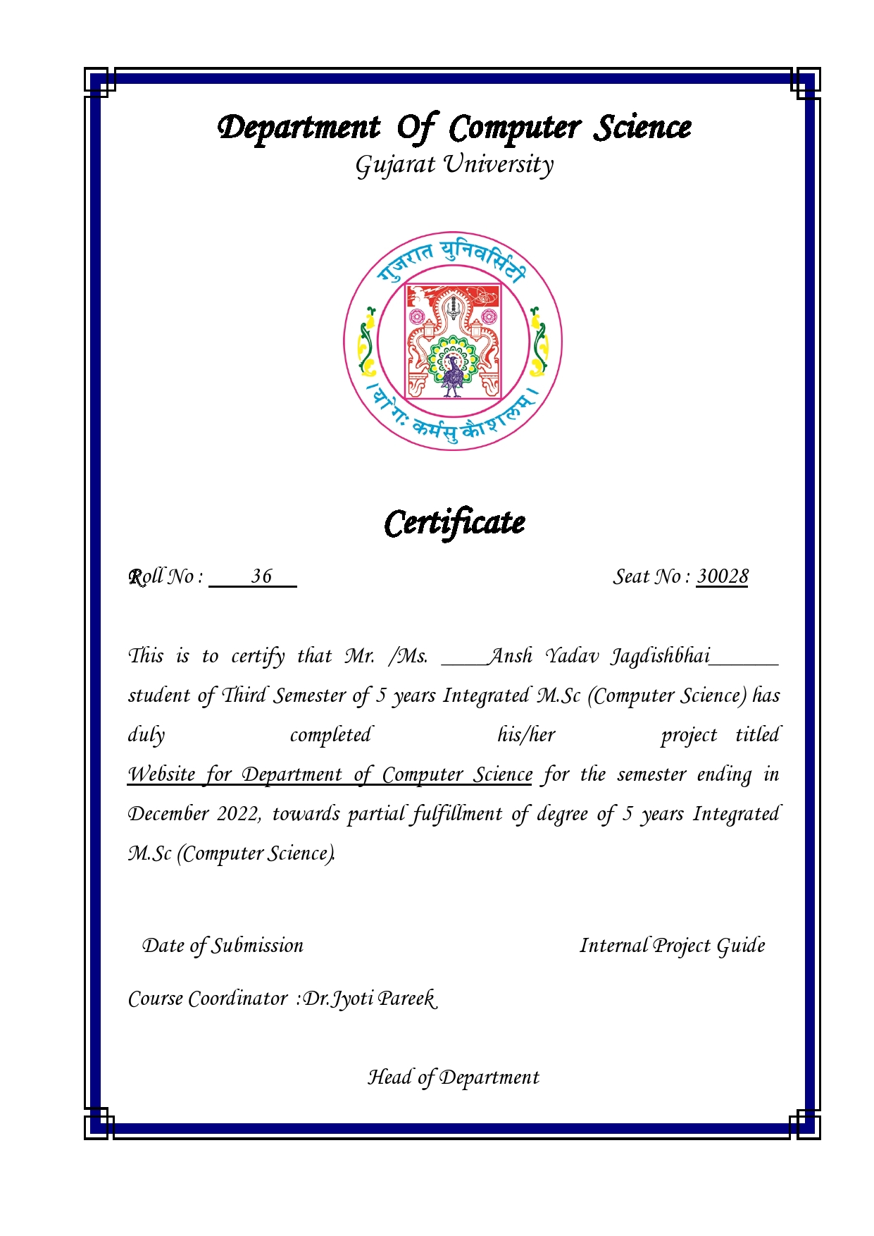

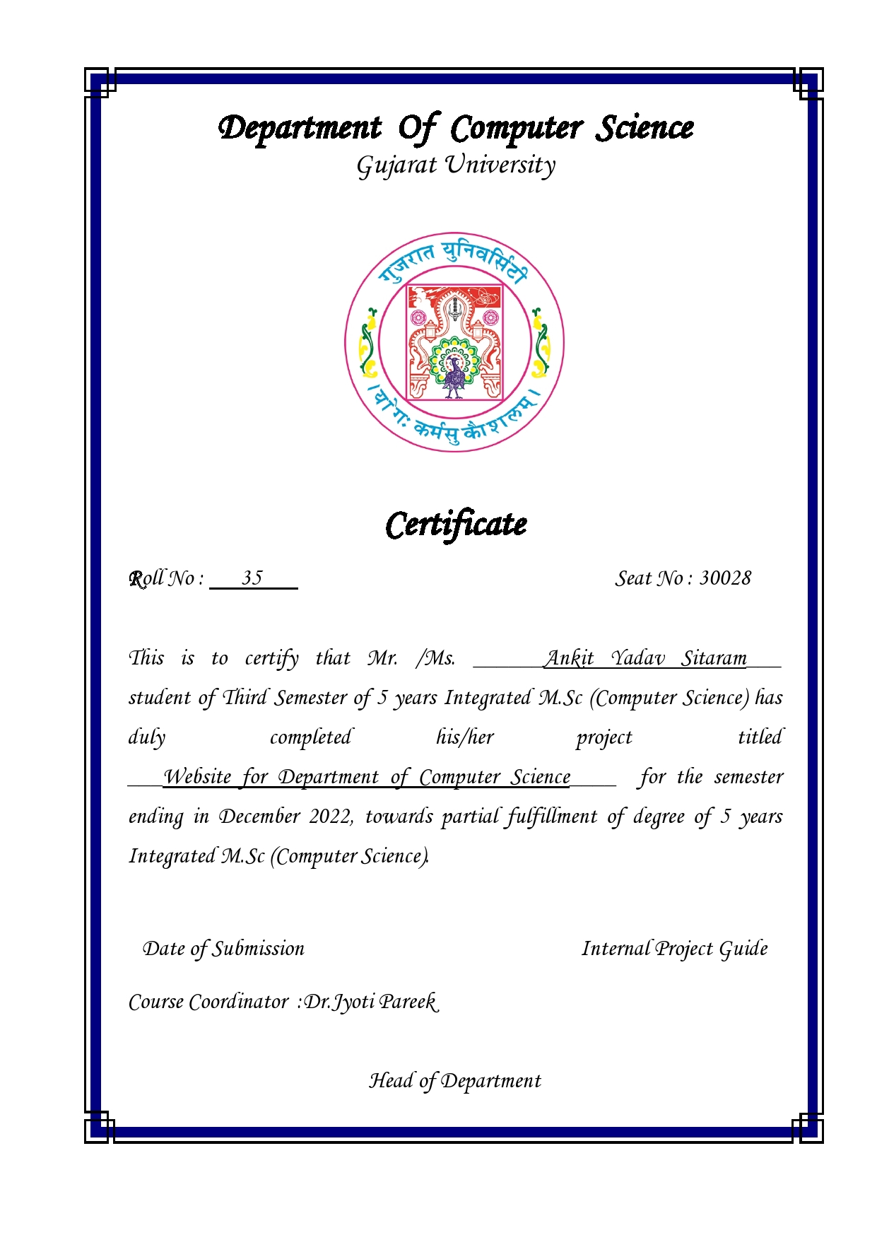

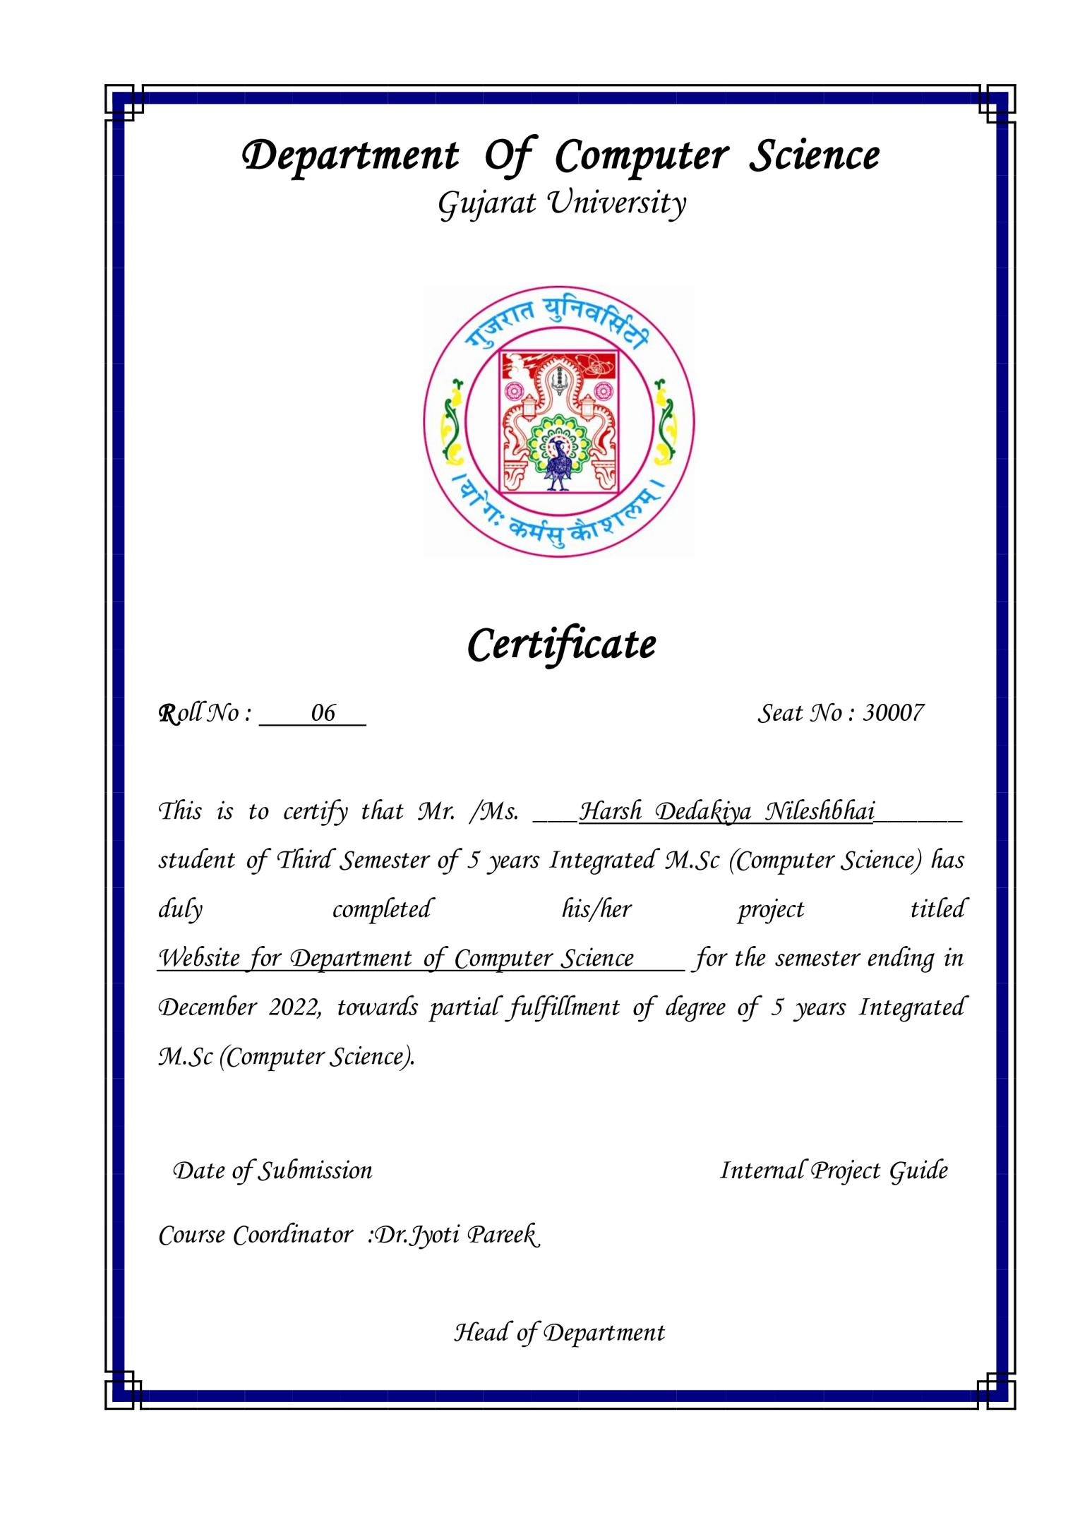

**ACKNOWLEDGMENT**

I take this opportunity to express my heartiest gratitude to many who extended their helping hand and inspiration during the project. The successful completion of this project work stands on the shoulder of the people who have helped us directly or indirectly.

I am very much grateful to Dr. Jyoti Pareek, Head of the department for giving us a platform where my learning could be affirmed and implemented, also my gratitude to my internal guide Dr. Khyati Rami, Professor at Department of Computer Science, Gujarat University. Under whose interest, guidance and constant supervision at any stage of work have been the greatest help for us in bringing out this work in the present shape.

I am indebted to my other faculty members and an internal guide for motivating me and fostering a feeling of belongingness towards my alma mater. Their helpful solutions and comments enriched by their experience for the betterment of the project. I sincerely acknowledge that without his support this project would not have been feasible.

Finally, I would like to thank everyone who directly or indirectly helped us in the project.

**With Thanks to All**

Ansh Yadav

Harsh Dedakiya

Ankit Yadav

**TABLE OF CONTENT**

Department of Computer Science

2

* Project Profile
* Project Description
* Tools and Language
* Website Module
* System Design
* Data Dictionary
* Screenshots
* Future Work
* Bibliography

**PROJECT PROFILE**

* Website for “Maharishi Pingla , School of

Advance computing and information technology”.

* A detail Information is provided in the website

About the Department of Computer Science.

* It is a website for the Department of Computer

Science in which there is different login for

Different Authorities like Student Faculty. It also include detail about events happening in the

Department.

* It contain necessary information about course it’s syllabus eligibility and it’s also have detail about Faculties, in Faculty the Research Work Done and their Achievements are shown.

**PROJECT DESCRIPTION**

* Provided information are:Different login for

Different Authorities - Student , Faculty and Admin.

* Detail about All Events .
* There is information about Course and it's Syllabus eligibility .
* Admin can Manager Faculty and Student Details.
* Details about faculties , in addition to a facultycan

also shared their achievements and the research work paper done by them . Faculty also can Manage their Research Work .

**Tool & Language**

* **Front End Tools**
* Bootstrap
* HTML
* CSS
* PHP
* JavaScript
* **Back End Tools**
* MySQL
* **Software Tools**
* VS Code
* XAMPP SERVER

**WEBSITE MODULE**

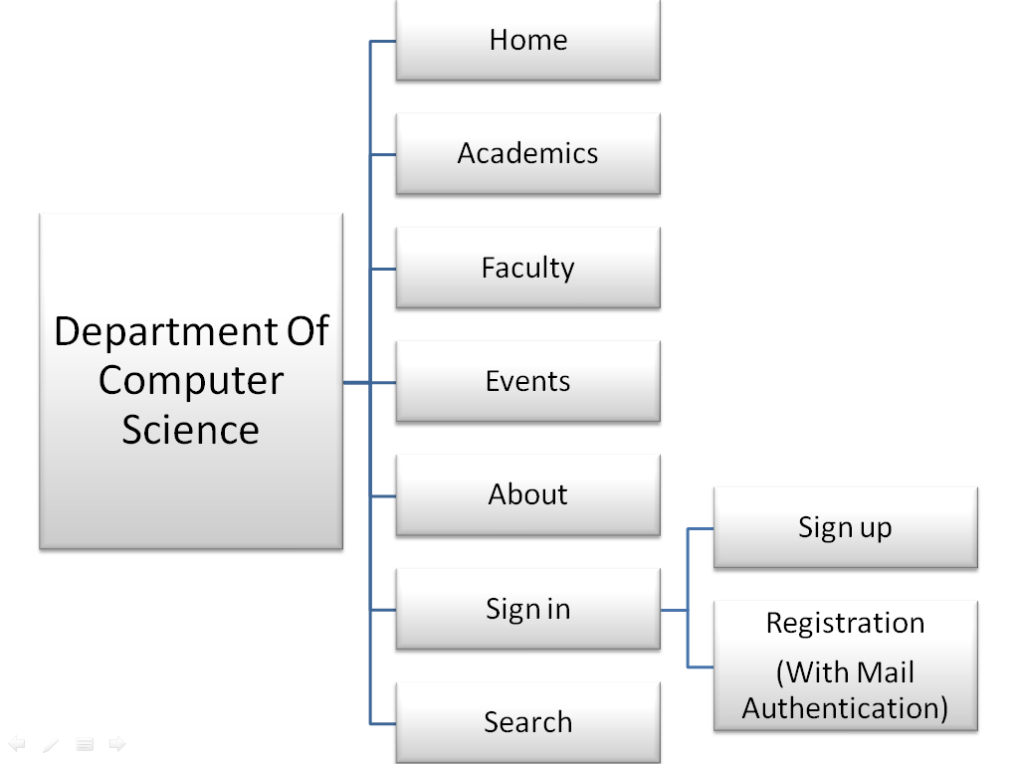

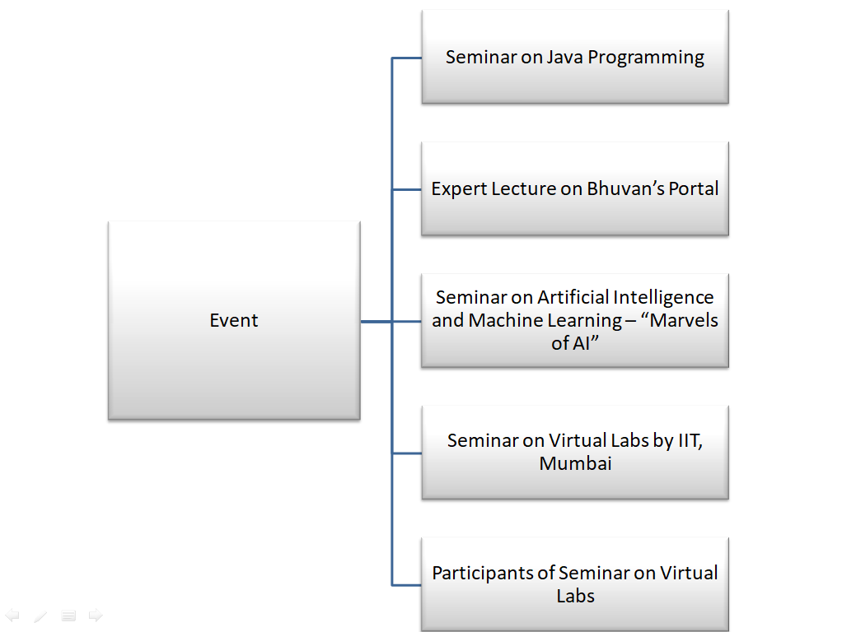

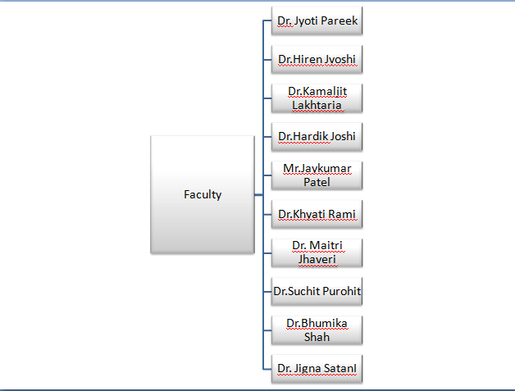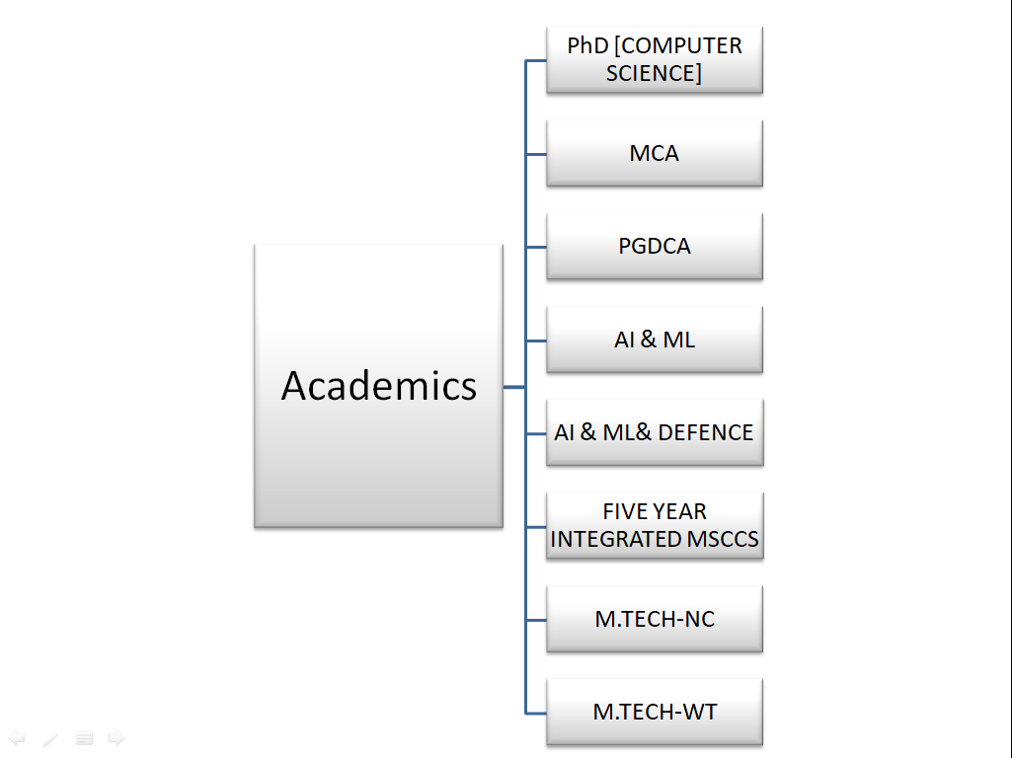

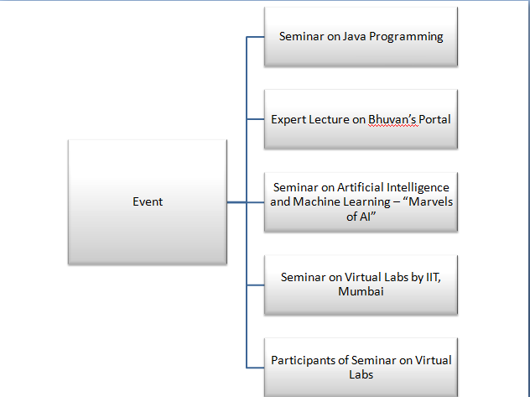

**Registration Process**

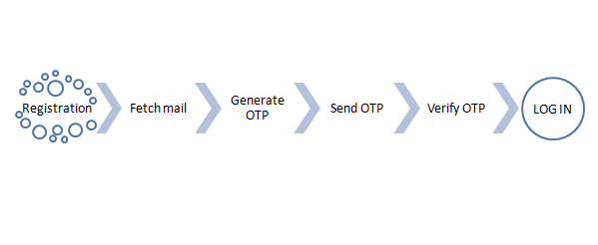

**Search Process**

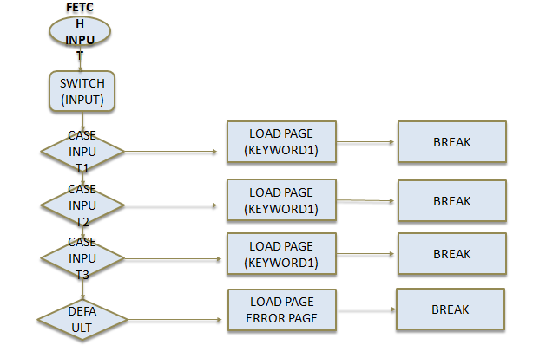

**Research Process**

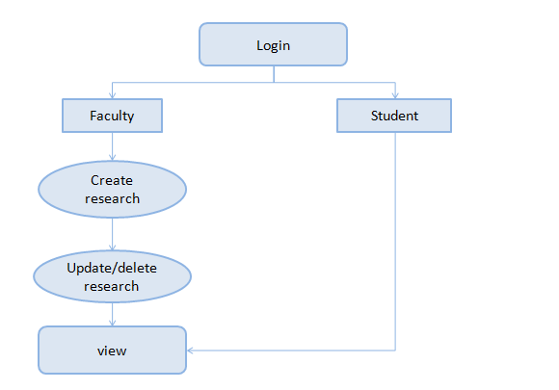

**EER MODEL**

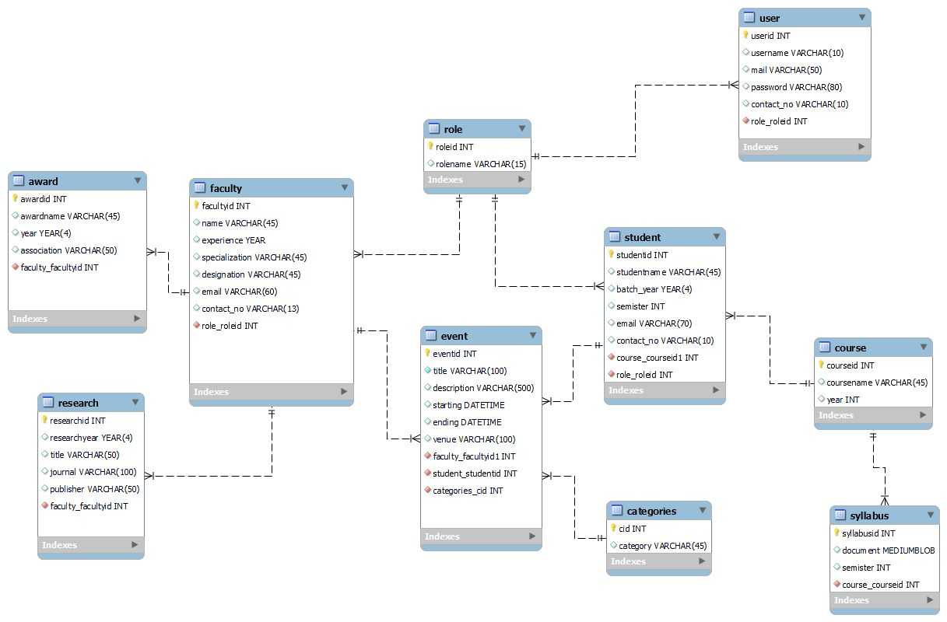

**Data Dictionary**

|  |  |  |  |  |  |
| --- | --- | --- | --- | --- | --- |
| **SERIAL NO** | **FIELD NAME** | **TYPE** | **SIZE** | **CONSTRAINS** | **SAMPLE DATA** |
| 1 | roleid | INT |  | Primary key | 1 |
| 2 | rolename | VARCHAR | 15 |  | admin |

ROLE TABLE

1

|  |  |  |  |  |  |
| --- | --- | --- | --- | --- | --- |
| **SERIAL NO** | **FIELD NAME** | **TYPE** | **SIZE** | **CONSTRAINS** | **SAMPLE DATA** |
| **1** | **userid** | **INT** |  | **Primary key** | **1** |
| **2** | **username** | **VARCHAR** | **10** |  | **kapil** |
| **3** | **mail** | **VARCHAR** | **50** |  | [**kapil@gmail.com**](mailto:kapil@gmail.com) |
| **4** | **password** | **VARCHAR** | **80** |  | **$2y$10$RxS965yWehIr.Vvq7VMKSOlMX.UYKQP/P0HVrZK3U5S3TzgeCSLyO** |
| **5** | **contact_no** | **VARCHAR** | **10** |  | **1234567890** |
| **6** | **role_roleid** | **INT** | **11** | **Foreign key,**  **Not Null** | |

USER TABLE

|  |  |  |  |  |  |
| --- | --- | --- | --- | --- | --- |
| **SERIAL NO** | **FIELD NAME** | **TYPE** | **SIZE** | **CONSTRAINS** | **SAMPLE DATA** |
| 1 | facultyid | INT |  | Primary key | 1 |
| 2 | name | VARCHAR | 45 |  | james |
| 3 | years_in_dcs | INT | 3 |  | 6 |
| 4 | specialization | VARCHAR | 45 |  | xyz |
| 5 | post | VARCHAR | 45 |  | Assistant projessor |
| 6 | email | VARCHAR | 60 |  | [james@gmail.com](mailto:james@gmail.com) |
| 7 | contact_no | VARCHAR | 13 |  | 1234567890 |
| 8 | role_roleid | INT |  | Foreign key, Not Null | 1 |

FACULTY TABLE

RESEARCH TABLE

|  |  |  |  |  |  |
| --- | --- | --- | --- | --- | --- |
| **SERIAL NO** | **FIELD NAME** | **TYPE** | **SIZE** | **CONSTRAINS** | **SAMPLE DATA** |
| 1 | researchid | INT |  | Primary key,Not Null | 1 |
| 2 | researchyear | YEAR | 4 |  | 2021 |
| 3 | title | VARCHAR | 50 |  | Experiments with Different Indexing   Techniques for Text Retrieval tasks  on Gujarati Language using Bag-of-Words Approach |
| 4 | journal | VARCHAR | 100 |  | xyz |
| 5 | publisher | VARCHAR | 50 |  | CIIT International Journal of Data Mining and  Knowledge Engineering |
| 6 | faculty_facultyid | INT |  | 2  Foreign key,  Not Null | |

AWARD TABLE

|  |  |  |  |  |  |
| --- | --- | --- | --- | --- | --- |
| **SERIAL NO** | **FIELD NAME** | **TYPE** | **SIZE** | **CONSTRAINS** | **SAMPLE DATA** |
| 1 | awardid | INT |  | Primary key | 1 |
| 2 | awardname | VARCHAR | 45 |  | nixi fellowship |
| 3 | year | YEAR | 4 |  | 2014 |
| 4 | association | VARCHAR | 50 |  | nixi |
| 5 | work | VARCHAR | 70 |  | xyz |
| 6 | faculty_facultyid | INT |  | Foreign key, Not null | 2 |

|  |  |  |  |  |  |
| --- | --- | --- | --- | --- | --- |
| SERIAL NO | FIELD NAME | TYPE | SIZE | CONSTRAINS | SAMPLE DATA |
| 1 | eventid | INT |  | Primary key,Not null | 1 |
| 2 | title | VARCHAR | 100 |  | Bhuvan Portal |
| 3 | description | VARCHAR | 500 |  | Lecture of Bhuvan portal |
| 4 | management | VARCHAR | 45 |  | xyz |
| 5 | member | VARCHAR | 45 |  | xyz |
| 6 | starting | DATETIME |  |  | 08-01-2023  02:30:00 |
| 7 | ending | DATETIME |  |  | 08-01-2023  02:30:00 |
| 8 | venue | VARCHAR | 100 |  | Conventional Hall |
| 9 | faculty_facultyid | INT |  | 2   |  | | --- | | Foregin key,  Not Null | | Foregin key,  Not Null | | |
| 10 | student_studentid | INT |  | 112 | |

EVENT TABLE

STUDENT TABLE

|  |  |  |  |  |  |
| --- | --- | --- | --- | --- | --- |
| **SERIAL NO** | **FIELD NAME** | **TYPE** | **SIZE** | **CONSTRAINS** | **SAMPLE DATA** |
| 1 | studentid | INT |  | Primary key | 1 |
| 2 | studentname | VARCHAR | 45 |  | alex |
| 3 | batch_year | YEAR |  |  | 2021 |
| 4 | email | VARCHAR | 70 |  | [alex@gmail.com](mailto:alex@gmail.com) |
| 5 | contact_no | VARCHAR | 10 |  | 1234567890 |
| 6 | course_courseid1 | INT |  | Foreign key, Not Null | 2 |
| 7 | role_roleid | INT |  | Foreign key, Not Null | 2 |

|  |  |  |  |  |  |
| --- | --- | --- | --- | --- | --- |
| **SERIAL NO** | **FIELD NAME** | **TYPE** | **SIZE** | **CONSTRAINS** | **SAMPLE DATA** |
| 1 | courseid | INT |  | Primary key | 1 |
| 2 | coursename | VARCHAR | 45 |  | integrated msc(cs) |
| 3 | year | INT |  |  | 5 |

|  |  |  |  |  |  |
| --- | --- | --- | --- | --- | --- |
| **SERIAL NO** | **FIELD NAME** | **TYPE** | **SIZE** | **CONSTRAINS** | **SAMPLE DATA** |
| 1 | syllabusid | INT |  | Primary key | 1 |
| 2 | document | MEDIUMBLOB |  |  | [BLOB - 35 B] |
| 3 | semister | INT |  |  | 3 |
| 4 | course_courseid | INT |  |  | 2 |

SYLLABUS TABLE

COURSE TABLE

|  |  |  |  |  |  |
| --- | --- | --- | --- | --- | --- |
| **SERIAL NO** | **FIELD NAME** | **TYPE** | **SIZE** | **CONSTRAINS** | **SAMPLE DATA** |
| 1 | cid | INT | 11 | Foreign Key | 1 |
| 2 | category | VARCHAR | 45 |  | Seminar |

CATEGORY TABLE

**Screenshots**

1. Home Page

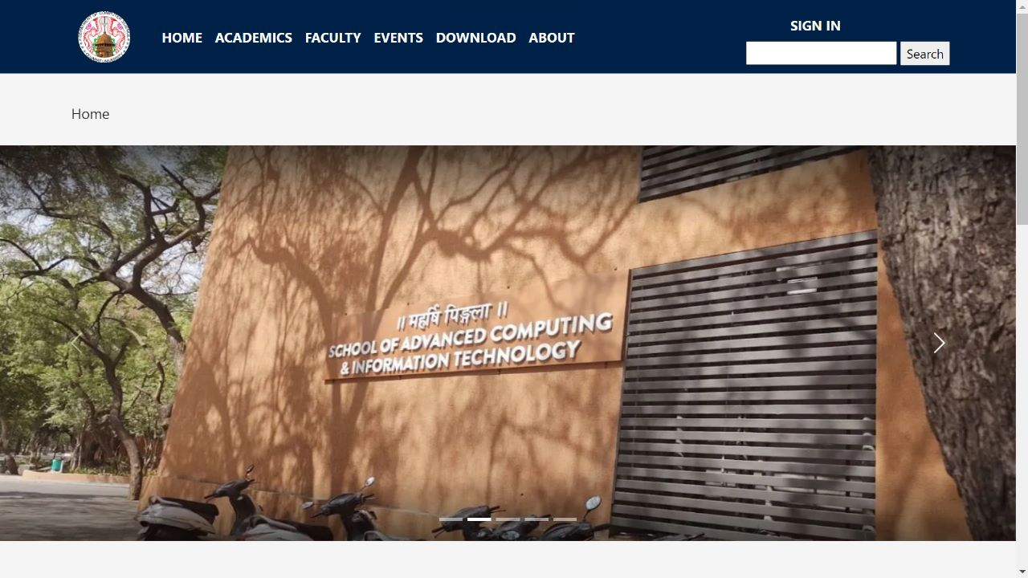

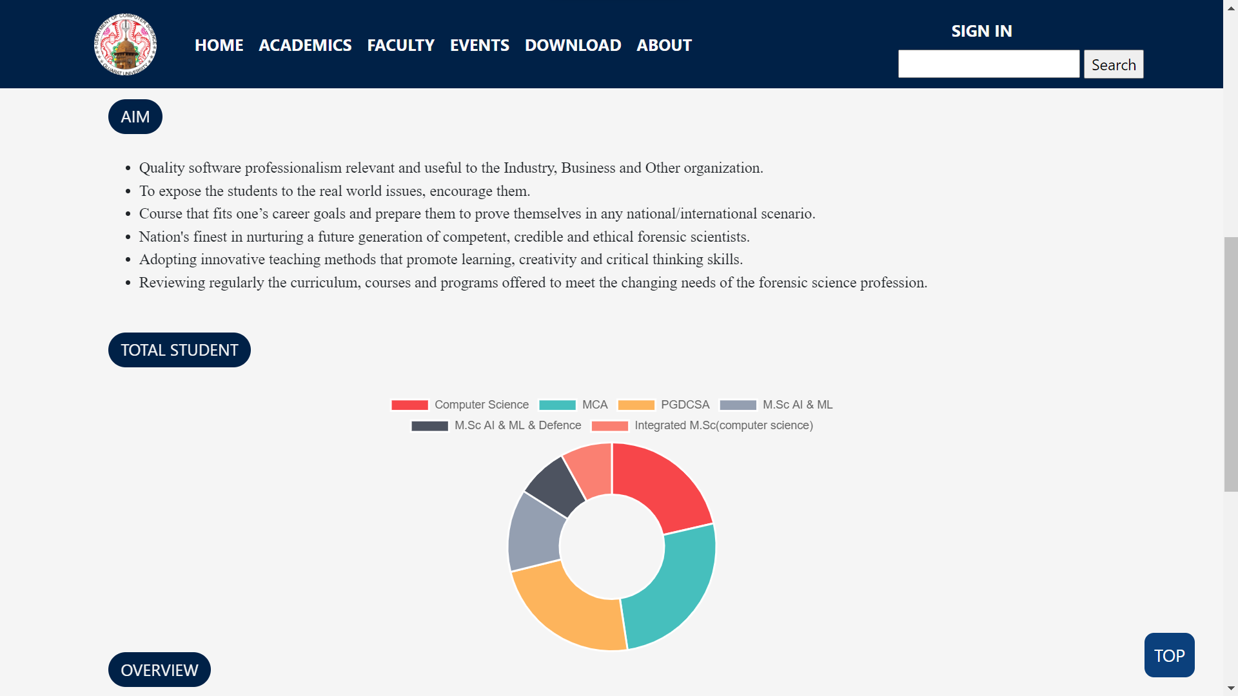

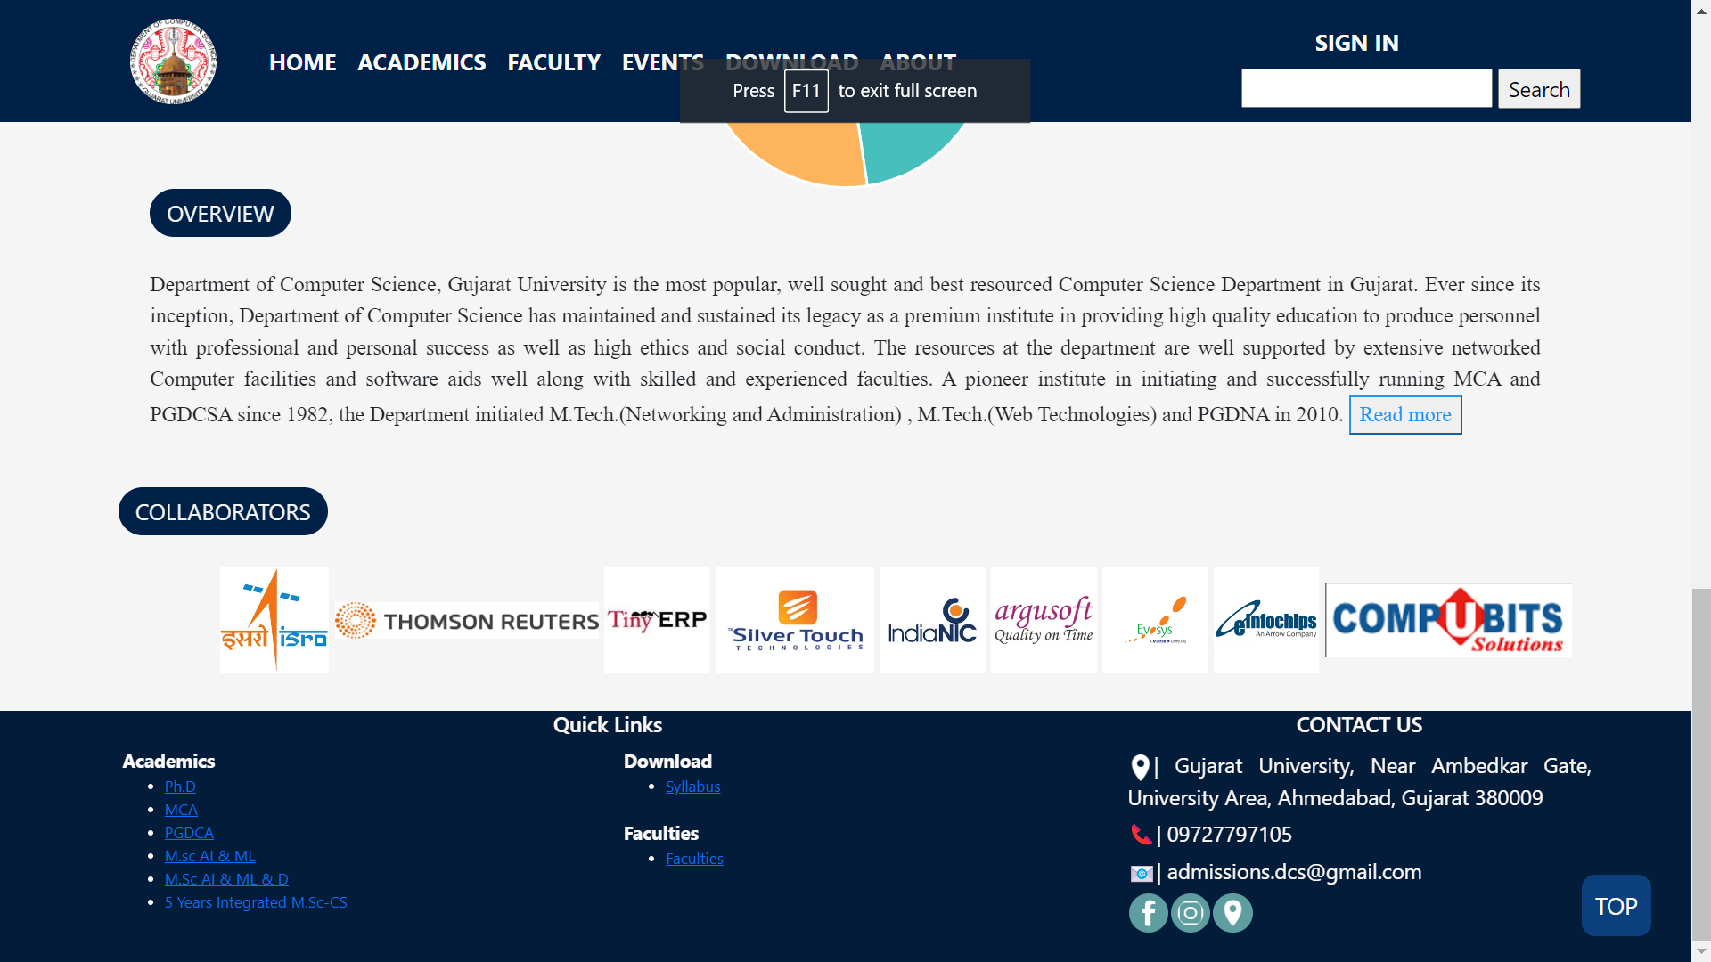

1. Header & Footer

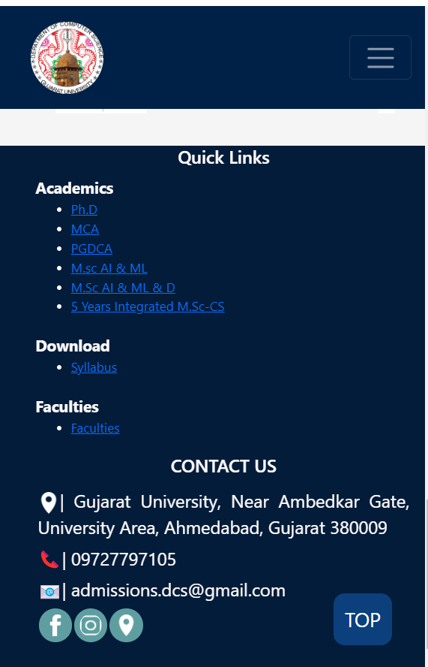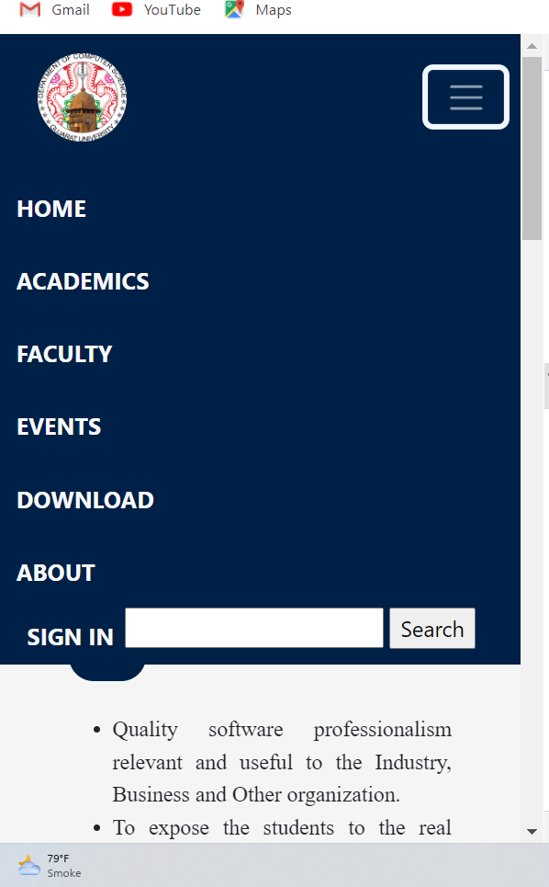

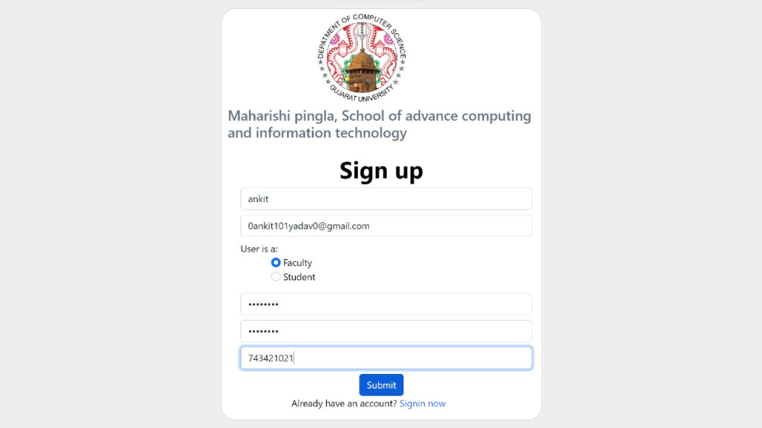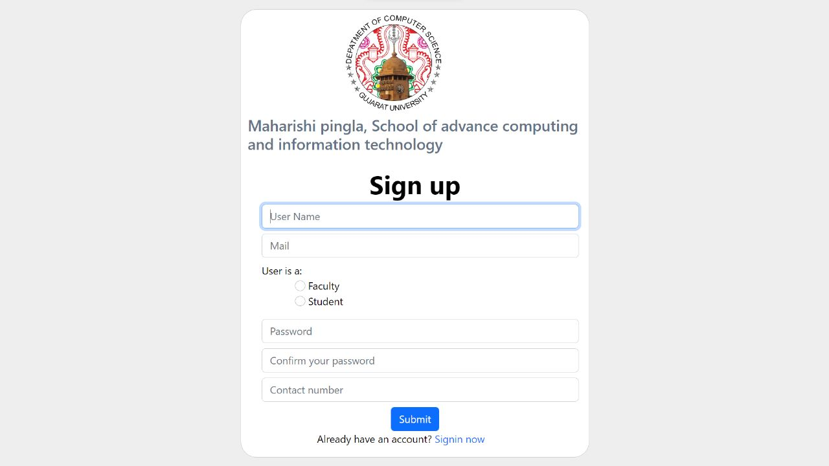

1. **Registration Process**
2. **Registration Process**

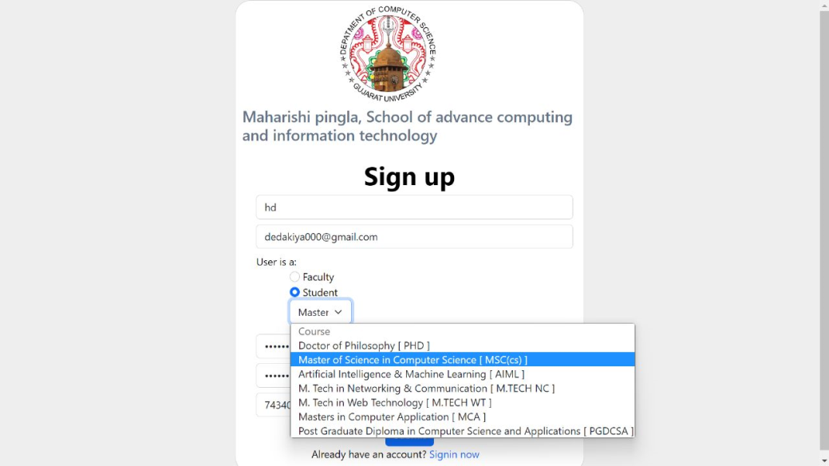

1. **Registration Process**

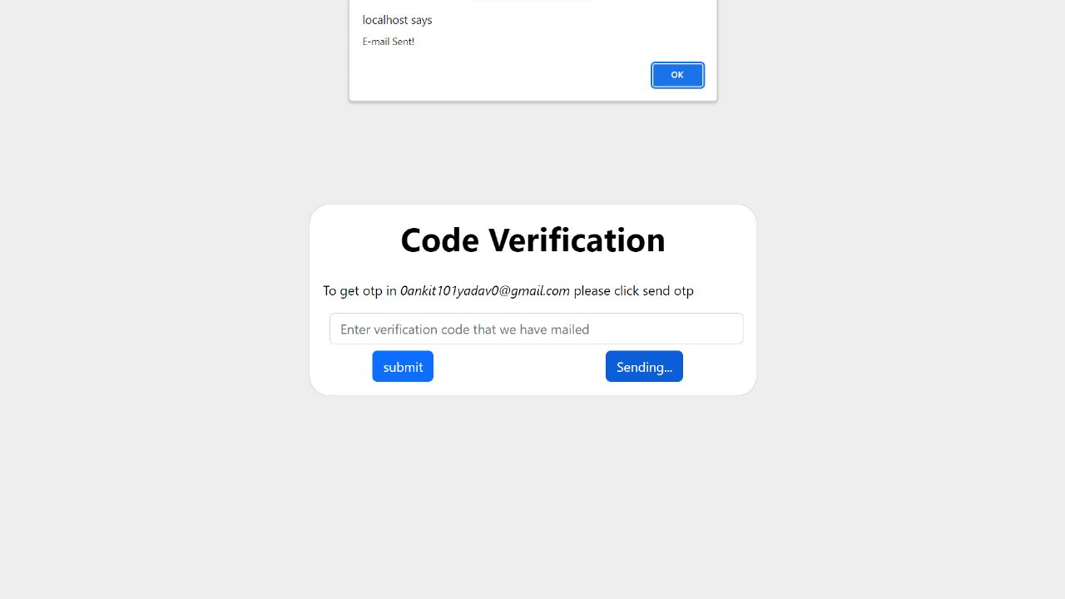

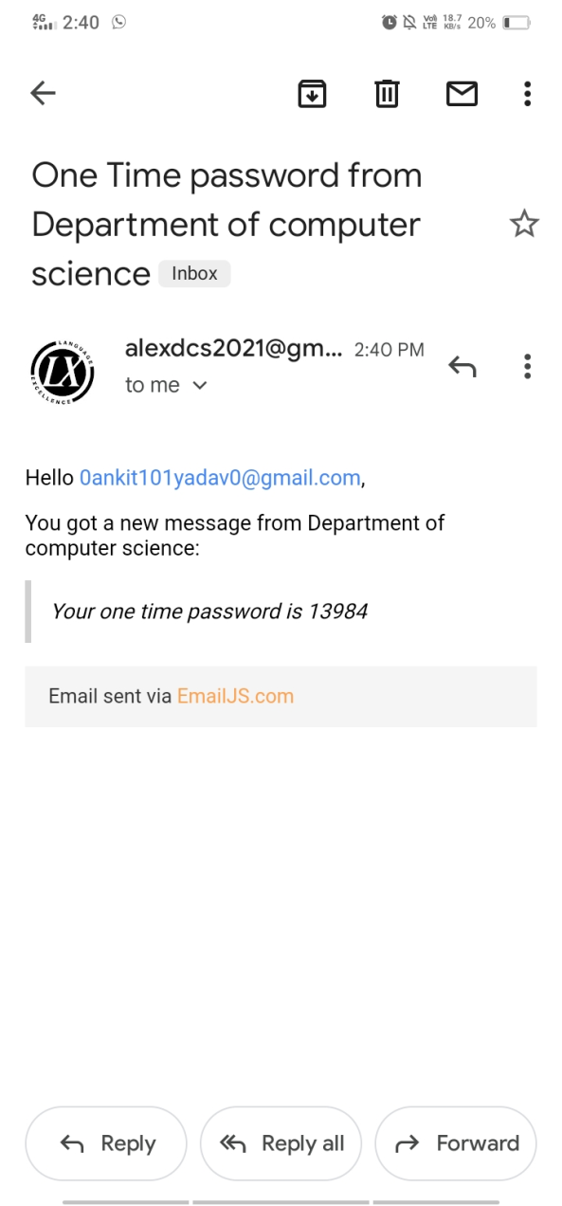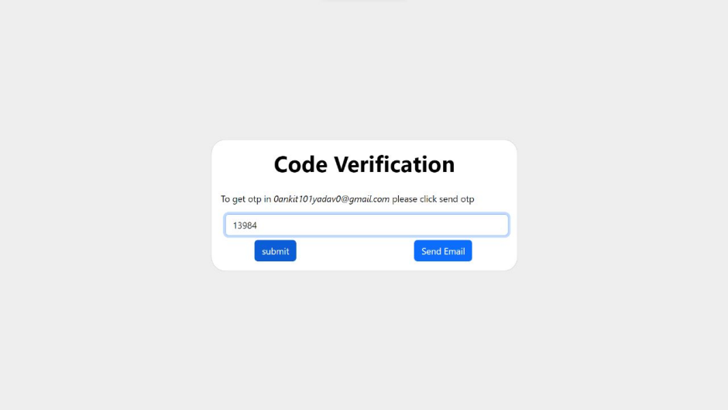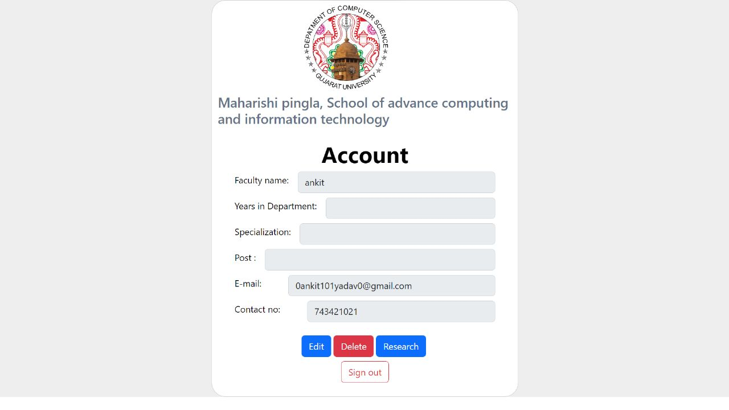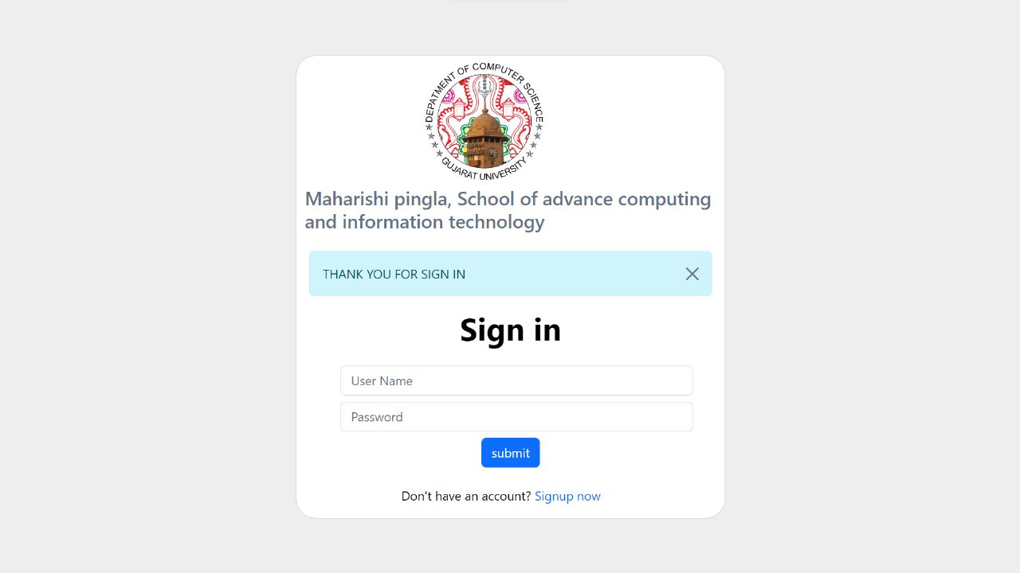

1. **Registration Process**
2. **Sign-In As A Faculty**
3. **Faculty Detail Update**
4. **Research Detail**

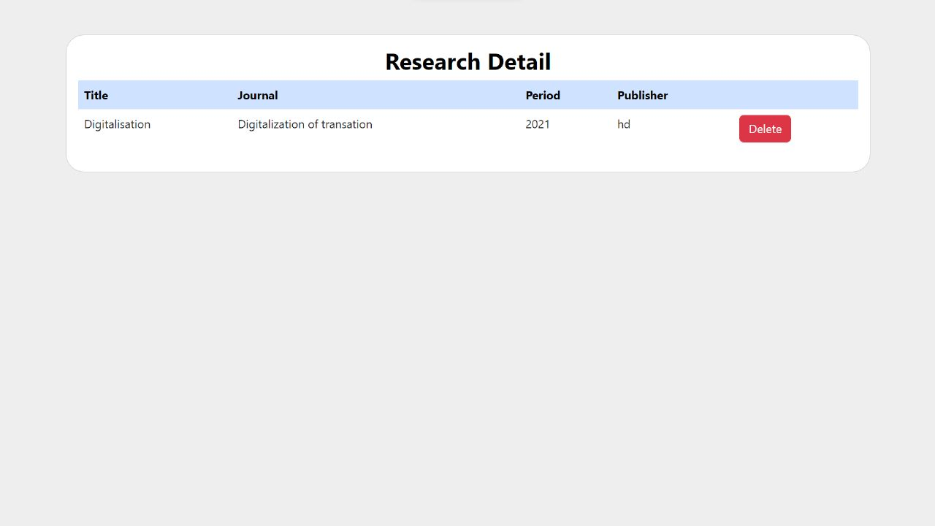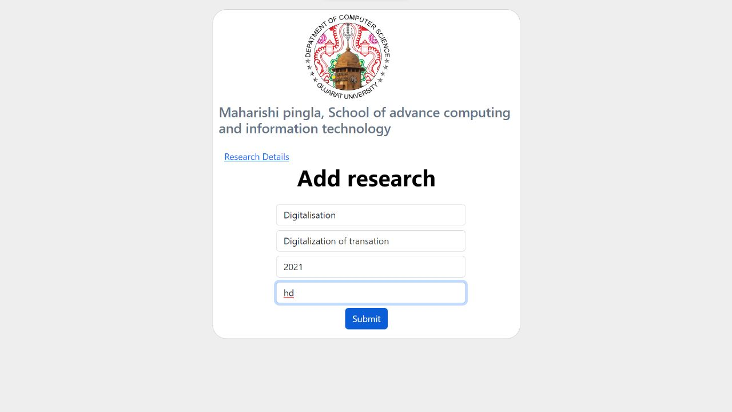

1. **Reg**
2. Syllabus Page

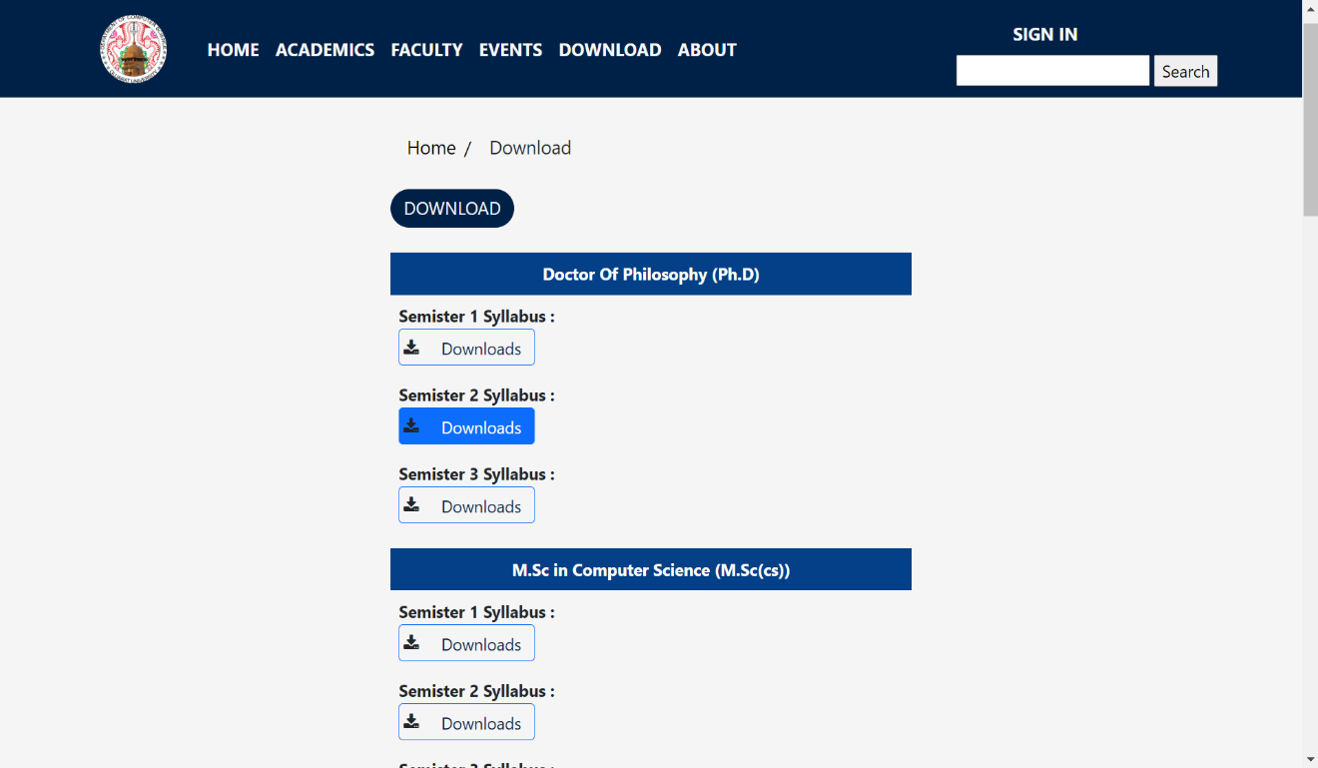

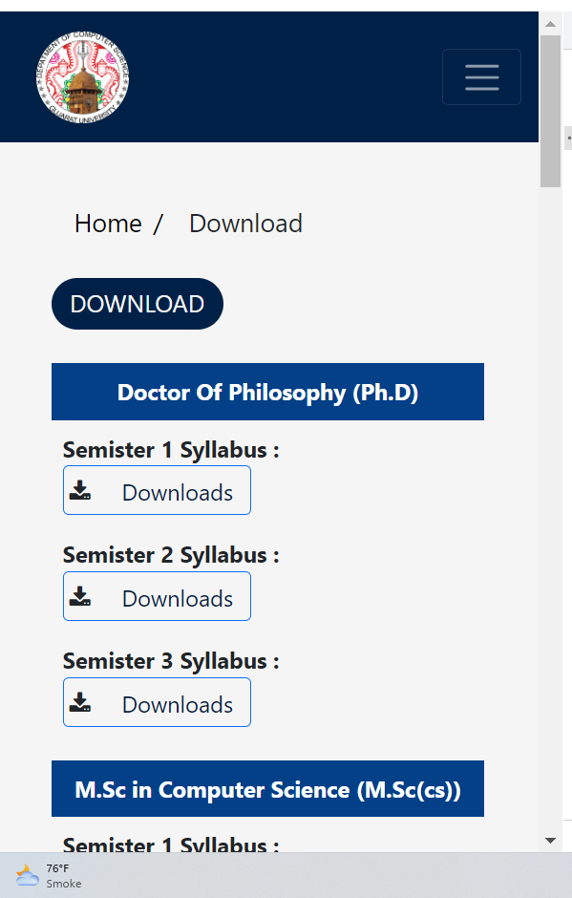

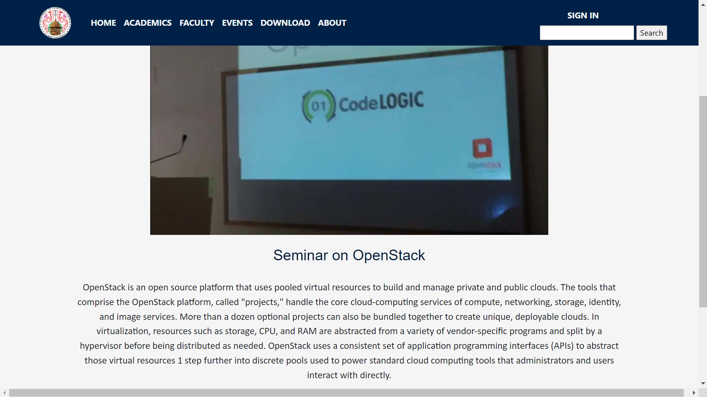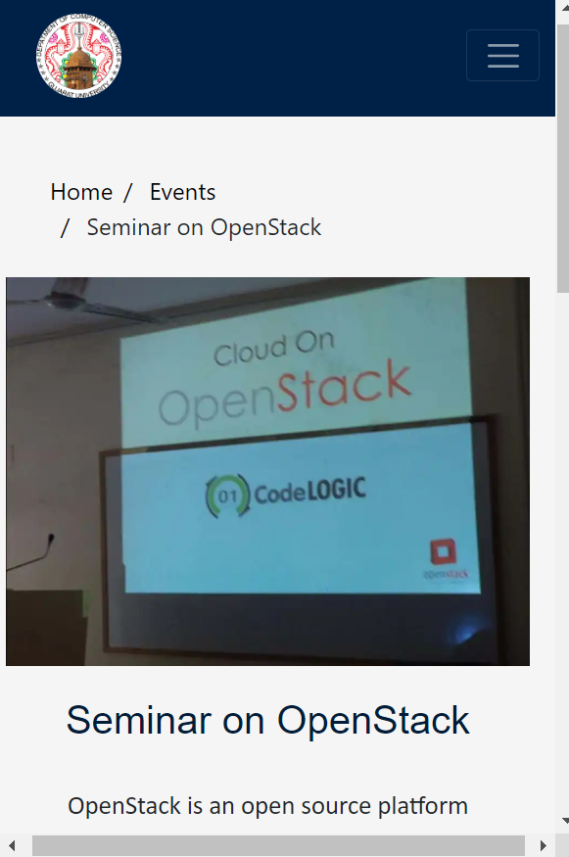

1. Event Page

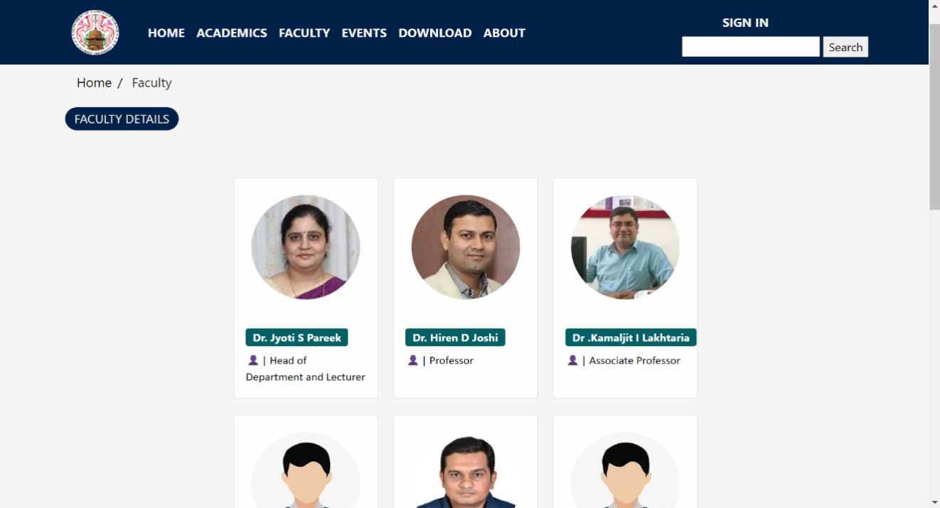

1. Faculty Page

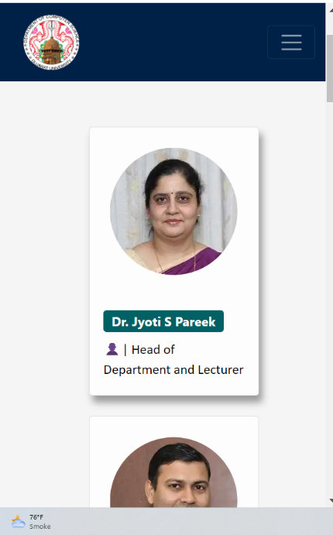

1. Faculty Page

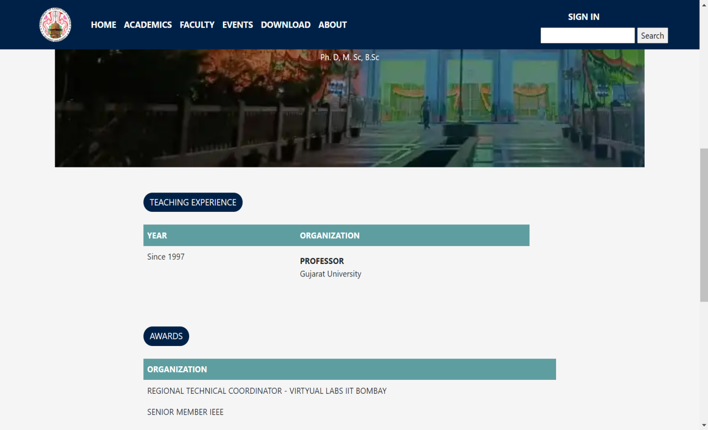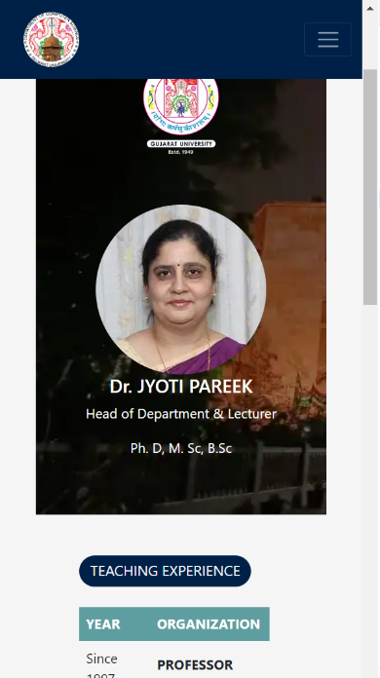

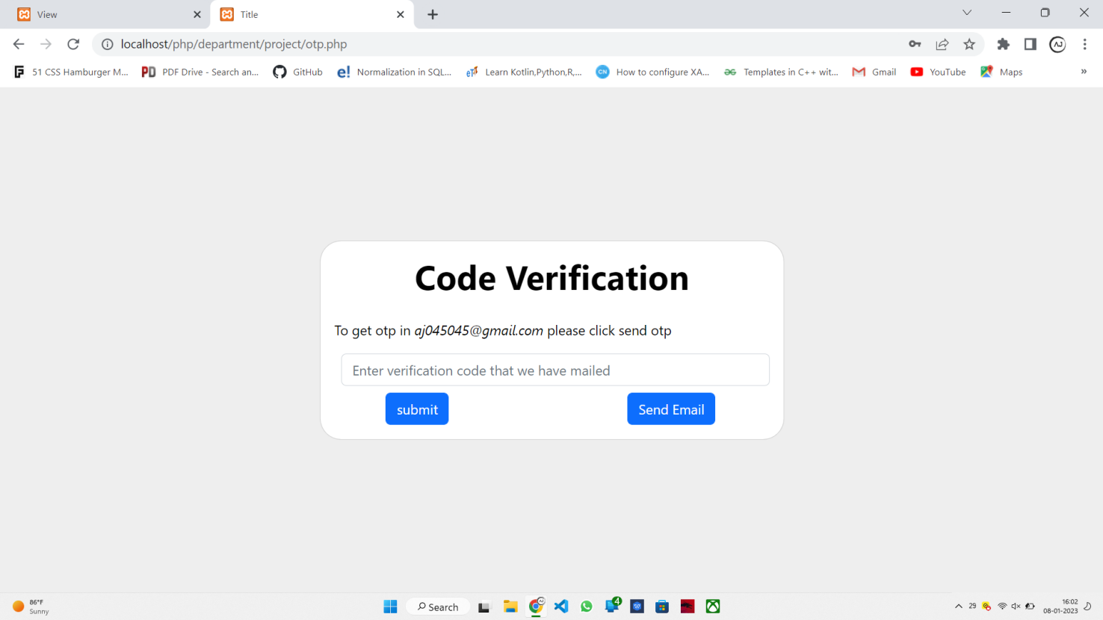

1. Code Verification

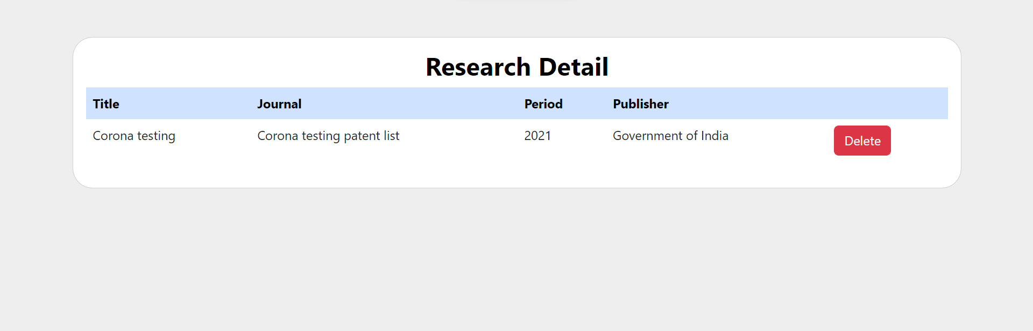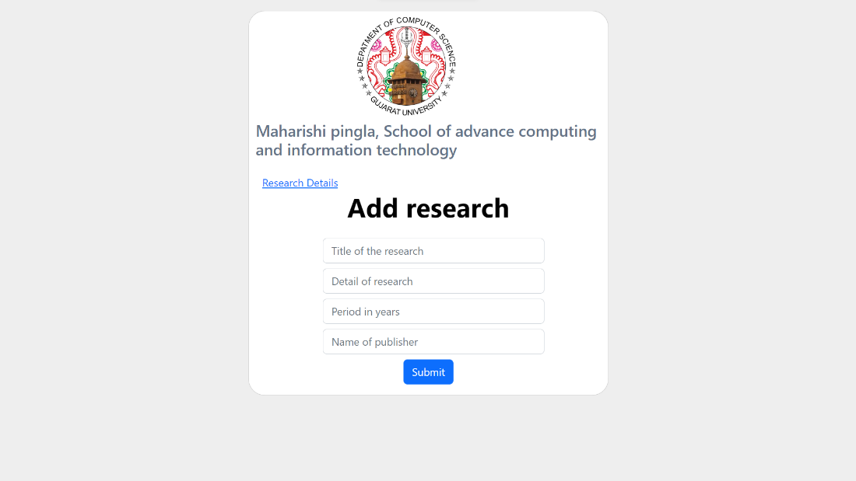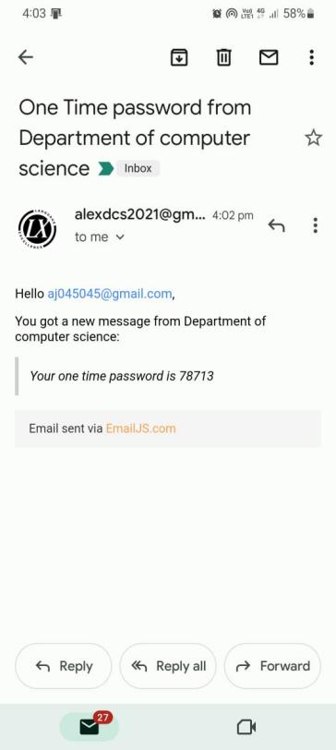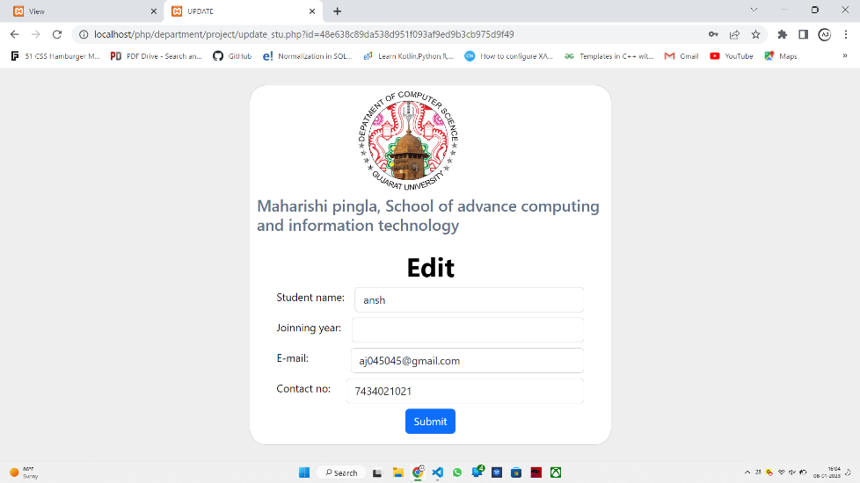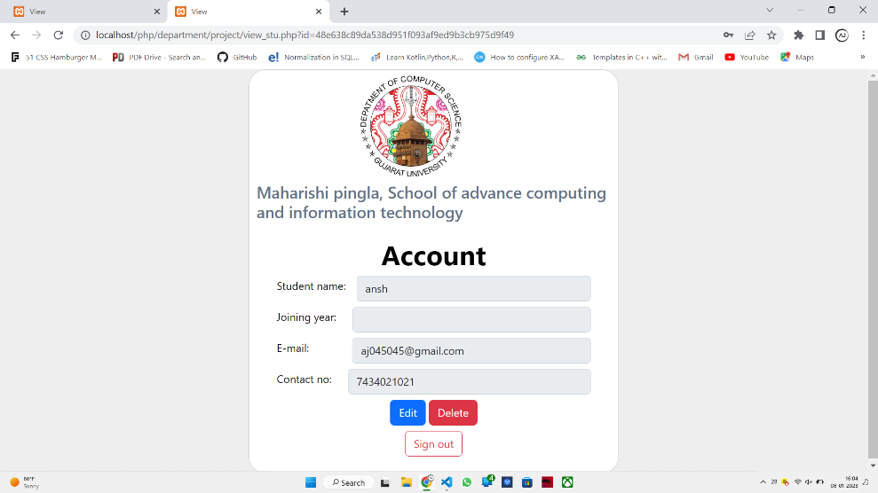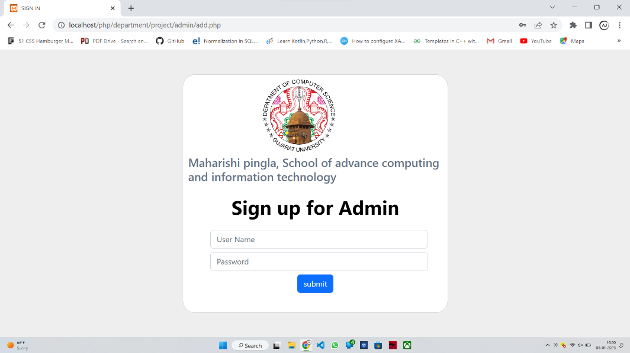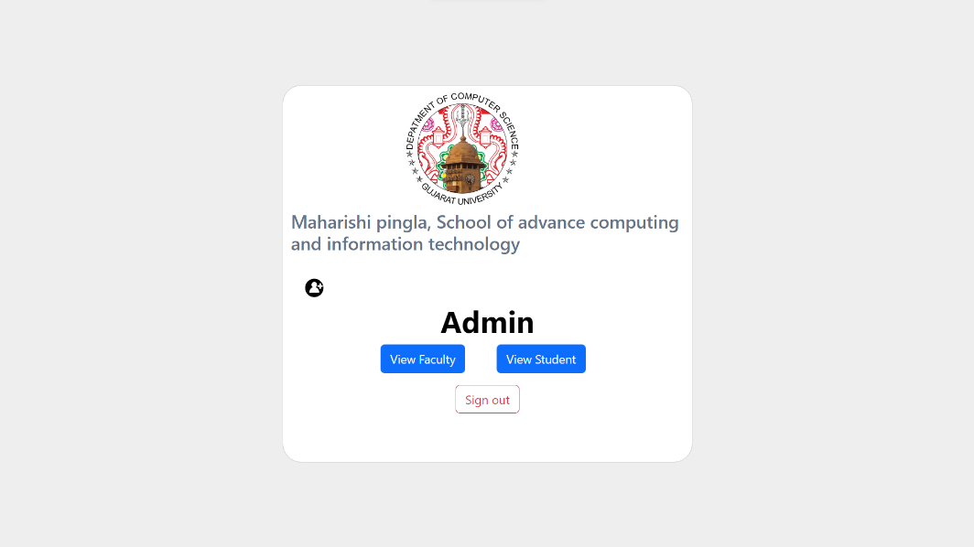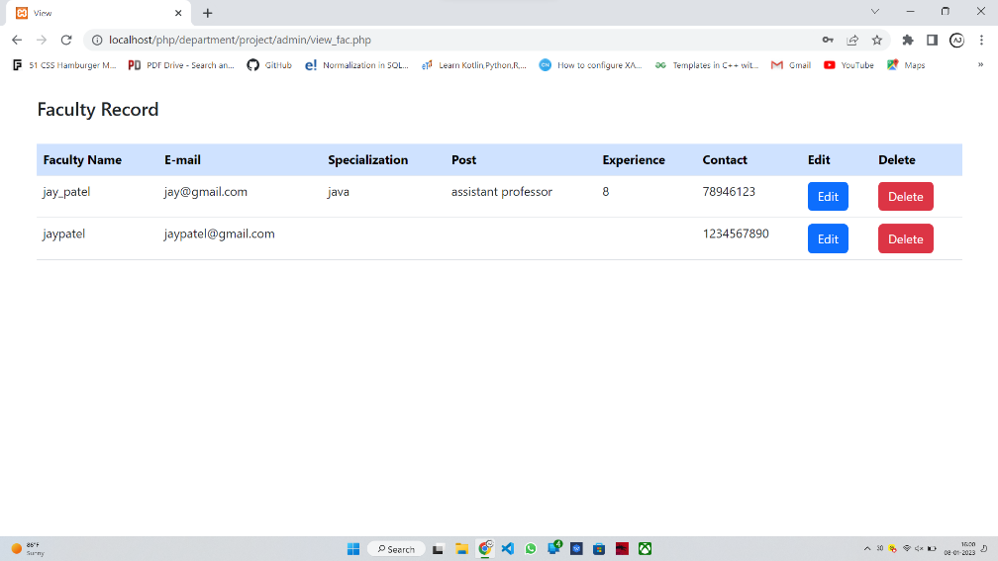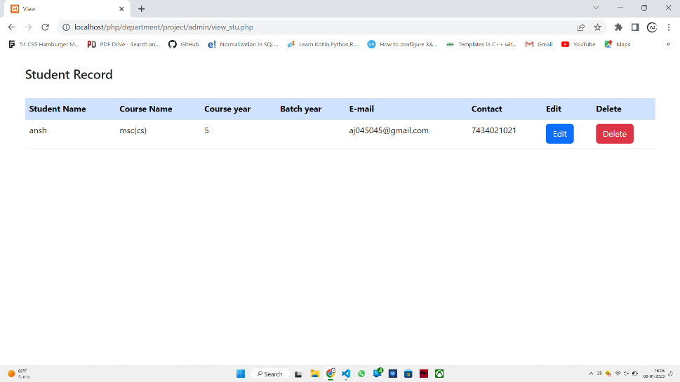

1. Research Page and it’s Detail
2. Edit & Account View
3. Admin
4. Admin As Student & Faculty

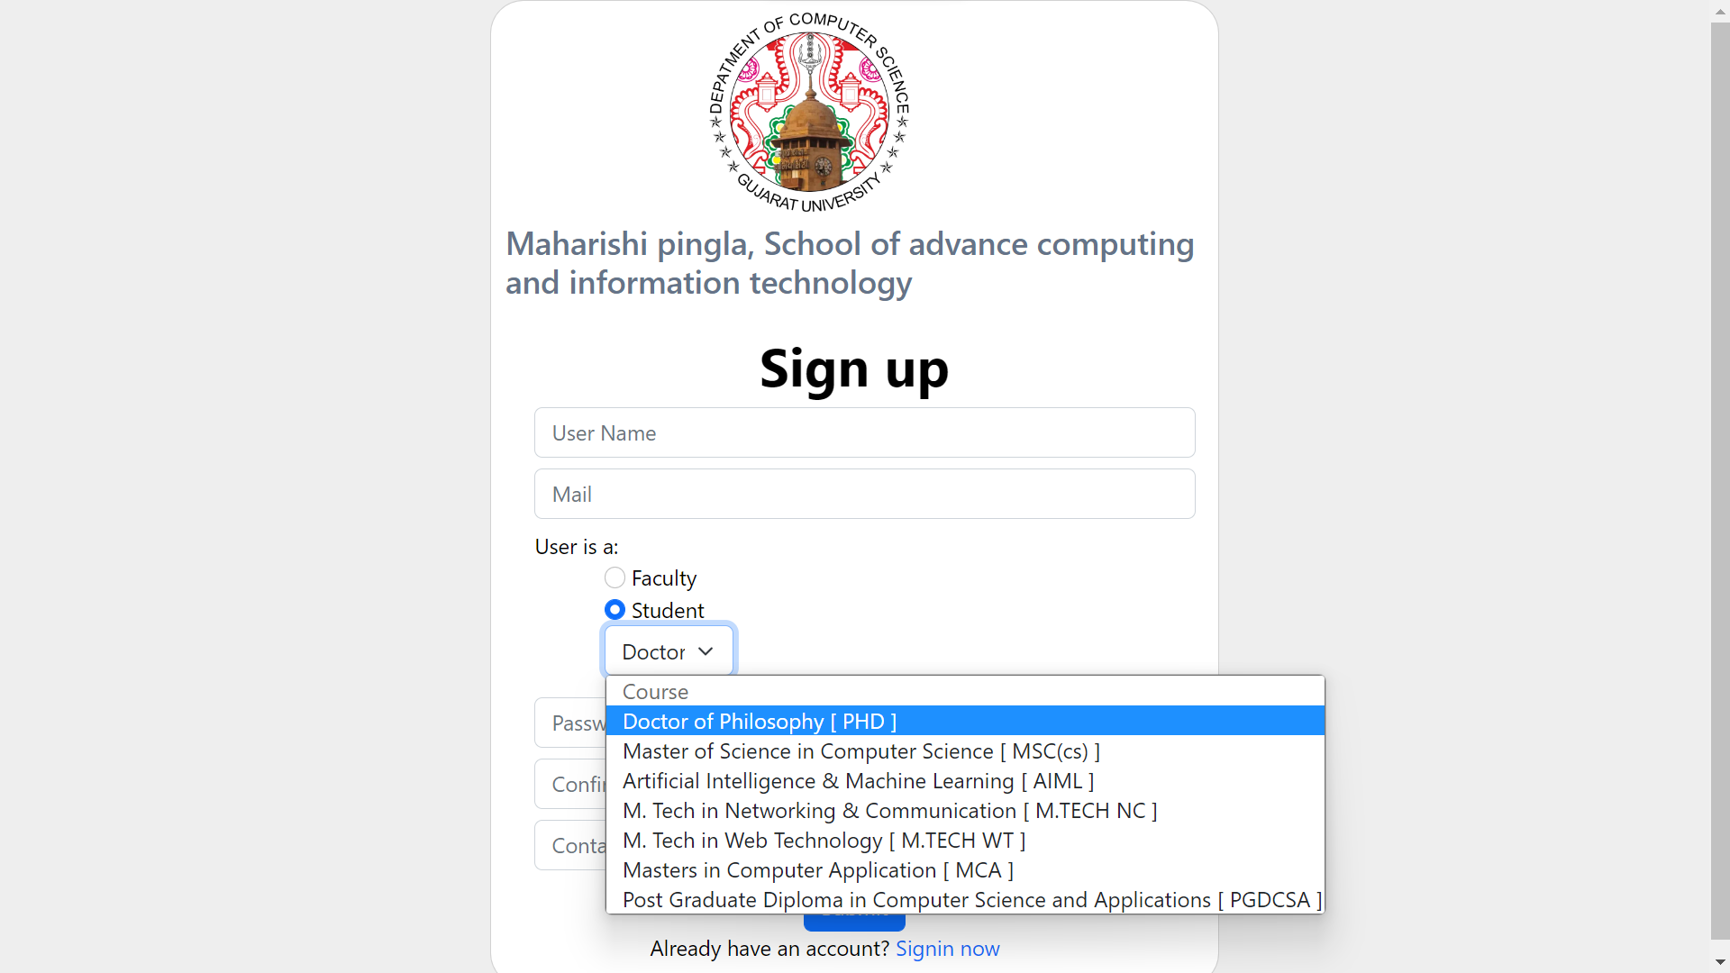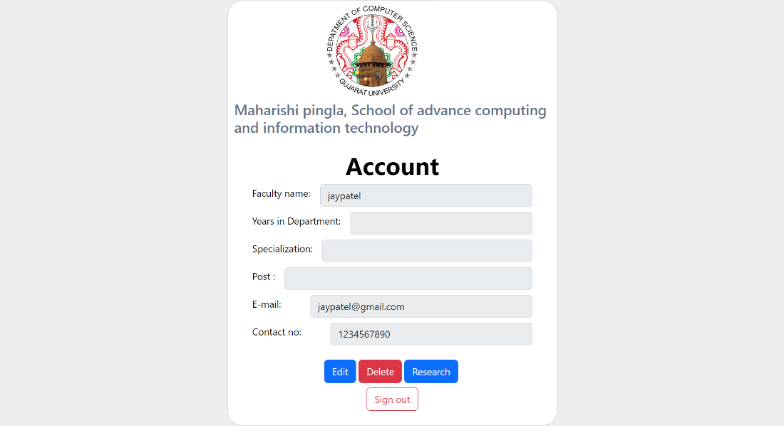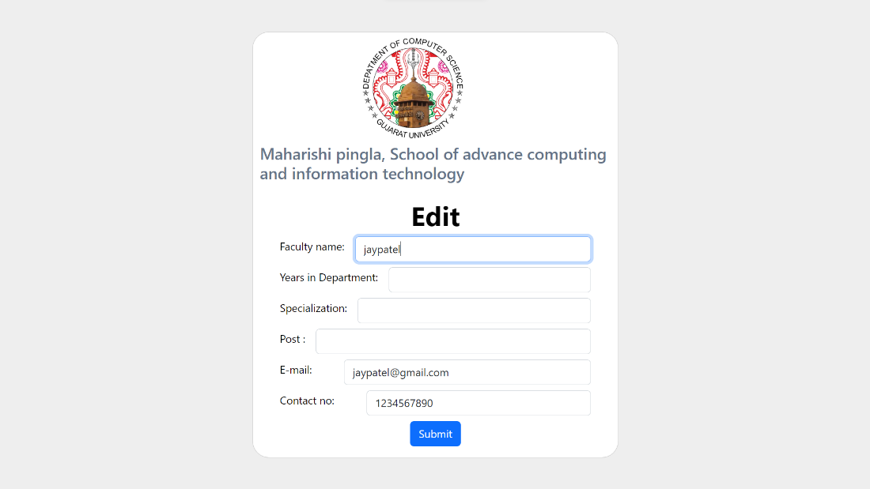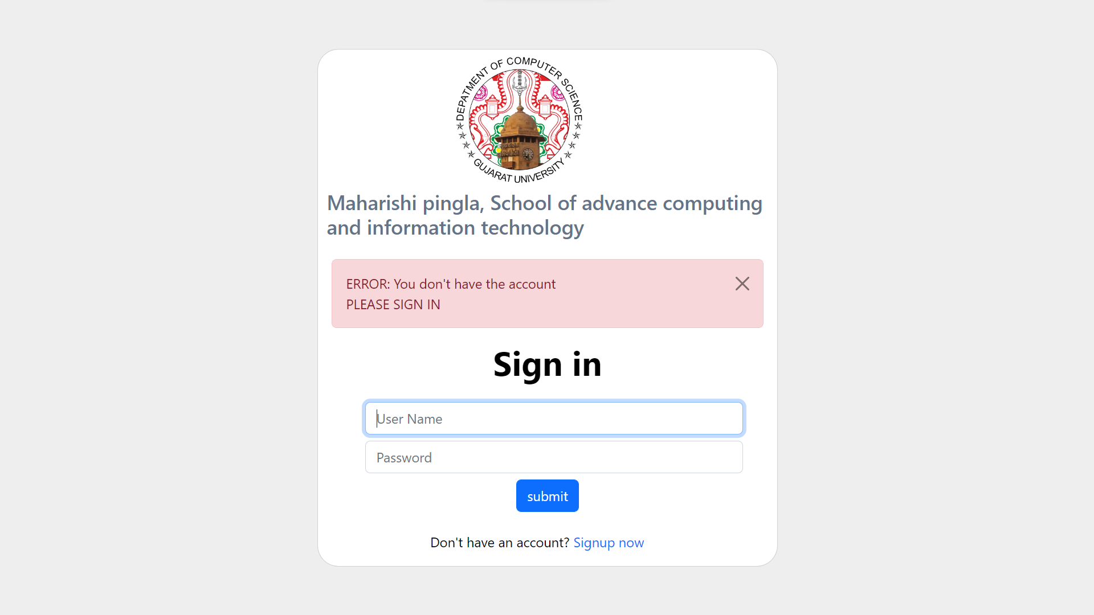

1. Sign-Up Page as Student
2. Faculty Account Management
3. Error

**FUTURE WORK**

* We can assure that if the Project get any implementation error under any Situation we are going do Up-gradation of Project Tools and if we needed will add new Features for Reusability and Interacting.
* In Future We are going to initiate new features like – News & Updates , Event Management (by the particular Portrayal) , Student can Download Syllabus Pdfs , etc. and Faculty Management.

**BIBILIOGRAPHY**

The term bibliography is the term used for a list of sources (e.g. research papers, reports, websites) used to do a Projects (e.g. a data).

References:

* Website of Gujarat university
* Website of Nirma University
* W3s
* getbootstrap.com

**Thank You**